Project 1
Analysis of Official Development Assistance (ODA) from DAC Donors

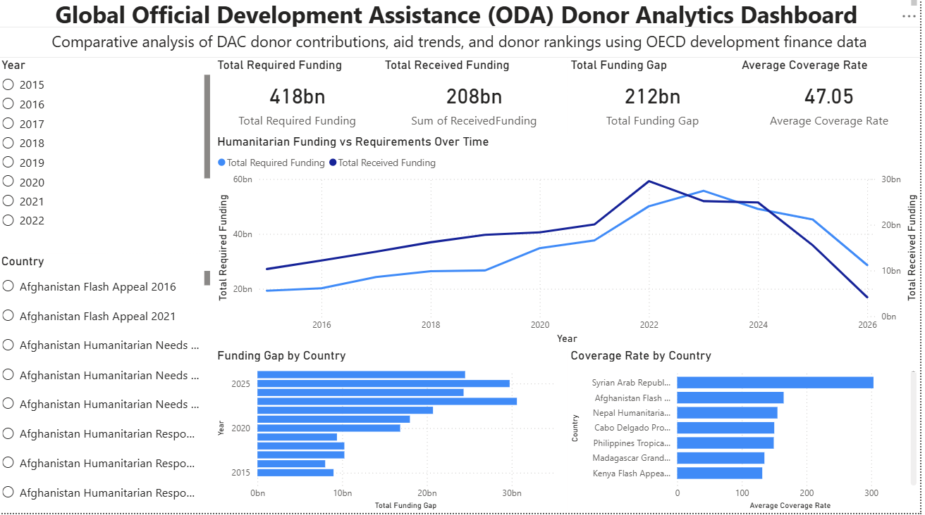
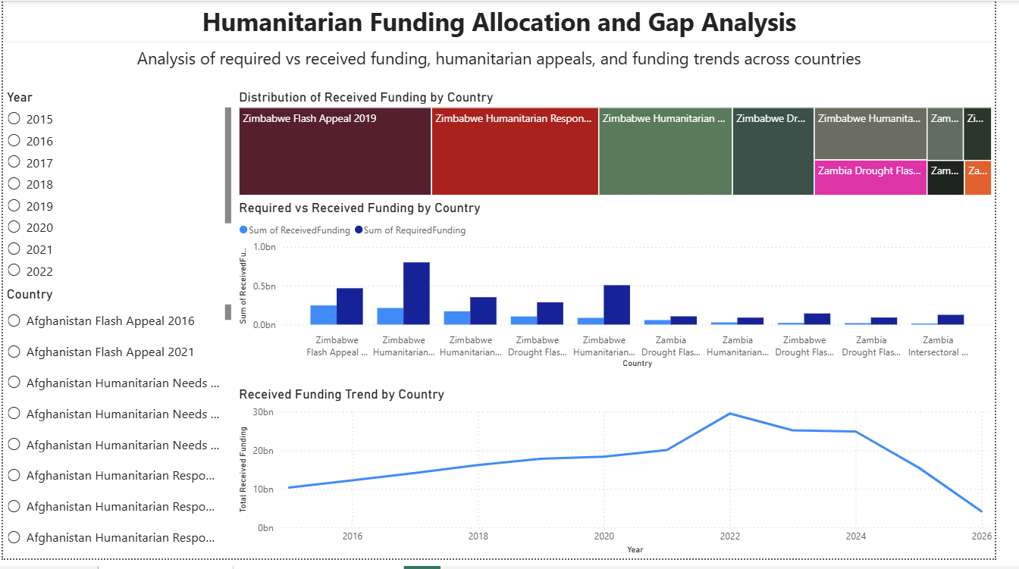

This dashboard analyzes trends in Official Development Assistance (ODA) provided by Development Assistance Committee (DAC) donor countries between 2005 and 2024. The analysis focuses on donor contributions, changes in donor rankings over time, overall aid trends, and the concentration of development assistance among major donors.
1. Largest ODA Donors
The analysis indicates that a small number of countries dominate global development assistance. The United States is the largest donor among DAC countries, contributing substantially more than any other country in the dataset. Germany and the United Kingdom follow as the second and third largest contributors, respectively.
Other major donors include France and Japan, which maintain significant but comparatively smaller levels of ODA contributions. A group of mid-tier donors, such as the Netherlands, Canada, Sweden, and Italy, also provides meaningful levels of assistance, though their contributions are notably lower than those of the largest donors.
Overall, the top five donor countries account for a significant share of total development assistance within the DAC system.
2. Changes in Donor Rankings Over Time
The donor ranking visualization indicates that the hierarchy of major ODA providers remains relatively stable throughout the observed period. The United States consistently maintains the top position, while Germany and the United Kingdom remain among the leading contributors over time.
Although minor fluctuations occur among mid-tier donors such as France and Japan, there are no dramatic shifts in the relative ranking of the largest contributors. Smaller donors remain consistently positioned in lower ranks across the period.
This stability suggests that global development financing continues to rely on a relatively consistent set of leading donor countries.
3. Trends in Total ODA Over Time
The time-series analysis reveals a general upward trend in total ODA contributions from DAC donors between 2005 and 2024. Following a slight decline in the mid-2000s, development assistance gradually increases through the late 2000s and early 2010s.
A particularly notable increase occurs after 2015, when overall aid flows begin to rise more significantly. The most pronounced growth appears between 2020 and 2023, when total ODA reaches its highest levels within the dataset.
This surge may reflect increased international spending in response to global crises, humanitarian needs, and development challenges during that period. After reaching a peak, aid levels show a slight decline in the most recent year.
4. Concentration of Development Assistance
The treemap visualization highlights a high concentration of development assistance among a small number of donor countries. The United States occupies the largest share of total ODA contributions, followed by Germany and the United Kingdom.
Together, these leading donors represent a substantial portion of overall DAC development assistance. In contrast, most other donor countries contribute significantly smaller shares of total funding.
This pattern indicates that global development financing is heavily dependent on a relatively small group of major economies.
Conclusion
The dashboard reveals several important patterns in global development assistance. ODA contributions are dominated by a small group of major donor countries, particularly the United States, Germany, and the United Kingdom. Donor rankings remain relatively stable over time, indicating a consistent structure within the global aid system.
At the same time, overall ODA levels have generally increased over the past two decades, with particularly strong growth observed in the early 2020s. Despite this growth, development assistance remains highly concentrated among a limited number of major contributors.
These findings highlight the continued importance of leading donor economies in shaping global development financing.

